The Lord of the Rings: The Two Towers
Figure 1 Aragorn

Santiago Moreno

Table of Contents
Table of Contents 2
Table of Figures 3
Table of Tables 4
Control Scheme 5
Aragorn 6
About 6
Combat 6
Combat Metrics 7
Attack 1 – Strider Dance 8
Attack 2 – Isuldur’s Penance 9
Attack 3 – Fang of Gondor 10
Enemies 11
Locked, Unlocked, Neutral 11
Ideal Chart 12
Lock/Unlock/Neutral Chart 12
Enemy 1 – Moria Goblin 13
Enemy 2 – Armored Goblin 14
Enemy 3 – Shelob Spawn 15
Enemy 4 – Uruk-Hai 16
Special Enemy 1 – Goblin Archer 17
Special Enemy 2 – Neekerbreekers 18
Special Enemy 3 – Shegob Spiderlings 19
Bibliography 20

Table of Figures
Figure 1 Aragorn 1
Figure 2 Control Scheme 5
Figure 3 Aragorn with his sword, Andúril 6
Figure 4 Aragorn Idle Pose 7
Figure 5 A group of Moria Goblins 13
Figure 6 Armored Goblin 14
Figure 7 Shelob herself 15
Figure 8 A group of Uruk-Hai 16
Figure 9 The Goblin Archer. 17
Figure 10 Angry Neekerbreekers 18
Figure 11 Shegob Spiderlings 19
Figure 12 Spiderling Sack, before bursting 19

Table of Tables
I. Strider Dance Input Guide 8
II. Strider Dance Stage 1 8
III. Strider Dance Stage 2 8
IV. Strider Dance Stage 3 8
V. Isuldur’s Penance Input Guide 9
VI. Isildur’s Penance Stage 1 9
VII. Isildur’s Penance Stage 2 9
VIII. Isildur’s Penance Stage 3 9
IX. Fang of Gondor Input Guide 10
X. Fang of Gondor Stage 1 10
XI. Ideal Lock/Unlock/Neutral Chart 12
XII. Actual Lock/Unlock/Neutral Chart 12
XIII. Moria Goblin Stats 13
XIV. Moria Goblin Attack 13
XV. Moria Goblin Lock/Unlock/Neutral 13
XVI. Armored Goblin Stats 14
XVII. Armored Goblin Attack 14
XVIII. Armored Goblin Lock/Unlock/Neutral 14
XIX. Shelob Spawn Stats 15
XX. Shelob Spawn Attack 15
XXI. Shelob Spawn Lock/Unlock/Neutral 15
XXII. Uruk-Hai Stats 16
XXIII. Uruk-Hai Attack 16
XXIV. Uruk-Hai Lock/Unlock/Neutral 16
XXV. Goblin Archer Stats 17
XXVI. Goblin Archer Attack 17
XXVII. Neekerbreekers Stats 18
XXVIII. Spiderling Stats 19

Control Scheme
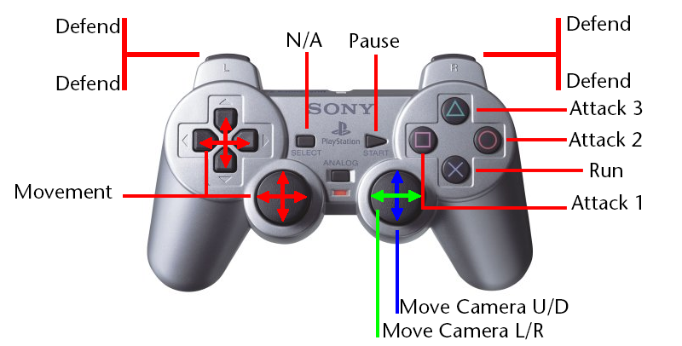
Figure 2 Control Scheme

Aragorn

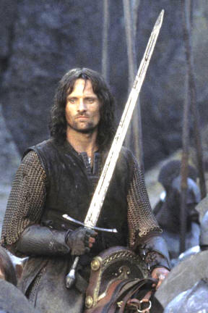
Figure 3 Aragorn with his sword, Andúril

About
Aragorn II Elessar, also known as Strider, fights alongside the Fellowship Of The Ring, with his longsword Andúril. An expert with the sword, the bow, and the dagger, few men match his skill in combat. He protects Frodo in his long journey to delivering the One Ring to Mt. Doom. Eventually, he ascends to the throne of Gondor as King. Bravery, an unbreakable will, and wisdom are his main characterizations, a product of his elven upbringing and royal heritage.

Combat
Aragorn fights primarily with his sword, with both one hand and two handed strikes. He uses his bow mostly whenever enemies are farther away and very rarely opts to fight with his dagger. This allows him to excel in close-mid range combat, with the option to transition into long-range combat should the need arise.

However, the purposes of this document, Aragorn only fights with in close-quarters one-on-one combat.
Seven attacks comprise Aragorn’s moveset. They filter into two different three-stage attacks (henceforth also referred to as combos) and one single-stage attack. In addition, Aragorn can also walk, run, and defend from attacks. When defending from attacks, the Aragorn takes no damage from enemy attacks, but cannot deal damage, either.
Using the appropriate button in succession strings combos together. The button must be pressed during the “attack” window, as detailed below.

Health
Aragorn’s health pool is of 1300 Units.

Combat Metrics
Attack times shown are in both frame units and seconds. All time measurements are in milliseconds (ms), unless otherwise stated. Each frame represents 1/30th of a second, or 33.33 milliseconds.
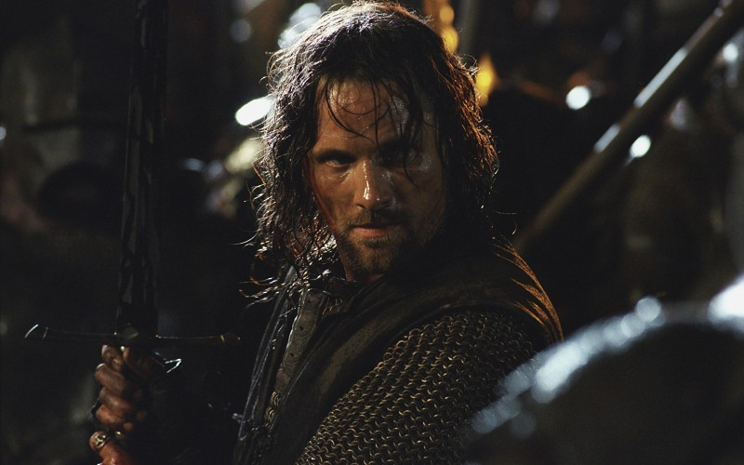
Figure 4 Aragorn Idle Pose
When idling, Aragorn holds his sword with both hands vertically, standing slightly to the side. When every attack ends, he must return to this position, referred to as his idle position.

Attack 1 – Strider Dance
□ -> | □ -> | □ ->
Stage 1 -> | Stage 2 -> | Stage 3
- Strider Dance Input Guide

Stage 1
Description: Aragorn swings horizontally, at height with his own neck, from left to right, using both hands.
Wind Up Time | Attack Time |  | Cooldown Time
8 frames/266.4ms | 5 frames/165.5 ms |  | 8 frames/266.4ms
Damage |  | 300
- Strider Dance Stage 1

Wind-Down: Aragorn must stabilize his body back into his neutral position, slowing down his spin.

Stage 2
Description: Aragorn spins in place, dealing another horizontal swing with only his right hand, this time at belly height.
Wind Up Time | Attack Time | Attack Time |  | Cooldown Time
8 frames/266.4ms | 5 frames/165.5 ms | 4 frames/133.32ms |  | 9 frames/299.97ms
Damage |  |  | 300 + 200
- Strider Dance Stage 2

Wind-Down: Aragorn must stabilize his body from the violent spin, as well as regain his footing.

Stage 3
Description: Aragorn lifts his left hand to meet his right hand above his head and to his right side, ending with a vertical swing downwards with both hands.
Wind Up Time | Attack Time | Attack Time |  | Attack Time | Cooldown Time
8 frames/266.4ms | 5 frames/165.5 ms | 4 frames/133.32 ms |  | 3 frames/99.99ms | 4 frames/133.32ms
Damage |  |  | 300 + 200 + 400
- Strider Dance Stage 3
Wind-Down: Aragorn lifts both hands up to his side.

Attack 2 – Isuldur’s Penance
○ -> | ○ -> | ○ ->
Stage 1 -> | Stage 2 -> | Stage 3
- Isuldur’s Penance Input Guide

Stage 1
Description: Aragorn swings his sword in an overhead strike over his right shoulder, using both hands.
Wind Up Time | Attack Time |  | Cooldown Time
7 frames/266.4ms | 5 frames/165.5 ms |  | 8 frames/266.4ms
Damage |  | 400
- Isildur’s Penance Stage 1

Wind-Down: Aragorn must raise his sword from the side of his left thigh back into his neutral position.

Stage 2
Description: Aragorn kicks the enemy before him with the plant of his right foot.
Wind Up Time | Attack Time | Attack Time |  | Cooldown Time
7 frames/233.31ms | 5 frames/165.5 ms | 4 frames/133.32ms |  | 4 frames/133.32ms
Damage |  |  | 400 + 150
- Isildur’s Penance Stage 2

Wind-Down: Aragorn must recover his balance by forcefully planting his right foot before returning both hands to his neutral position.

Stage 3
Description: Aragorn makes a horizontal swing with his right hand, at height with his midriff.
Wind Up Time | Attack Time | Attack Time |  | Attack Time | Cooldown Time
7 frames/233.31ms | 5 frames/165.5 ms | 4 frames/133.32 ms |  | 4 frames/99.99ms | 8 frames/266.4ms
Damage |  |  | 400 + 150 + 500
- Isildur’s Penance Stage 3

Wind-Down: Aragorn’s right hand stabilizes his sword while his left hand reaches to hold the hilt again.

Attack 3 – Fang of Gondor
△
Stage 1
- Fang of Gondor Input Guide

Stage 1
Description: Aragorn crouches slightly, and stabs forward with both hands, aiming at height with belly.
Wind Up Time | Attack Time |  | Cooldown Time
10 frames/333.3ms | 5 frames/165.5 ms |  | 10 frames/333.3ms
Damage |  | 700
- Fang of Gondor Stage 1

Wind-Down: Aragorn requires a brief pause, then raises his body along with his sword in both hands.

Enemies
The Fellowship Of the Ring encounter all sorts of creatures in their travels. From low goblins to gargantuan Ballrogs, their skills in combat must deal with anything. This section details seven different enemies, explaining in detail their health and attack capabilities. Three enemies are unique, however, due to requiring unique strategies than the rest.

Locked, Unlocked, Neutral
When Aragorn fights an enemy, he has several tools at his disposal. In order to quantify and expand on the strengths and weaknesses of each one, a chart is included that catalogs the relationship between each individual stage of each attack vs every enemy, and ranked as Locked, Neutral, or Unlocked. Each rank corresponds to how much health Aragorn takes when defeating this enemy with that specific stage.
- Locked: Defeating this enemy with this attack will require a considerable investment in health. Locked enemies deal more than 700 points of damage to Aragorn before dying.
- Neutral: Defeating many of this enemy requires some health. Neutral enemies deal between 400 and 600 health.
- Unlocked: Defeating this enemy requires little to no health investment. Unlocked enemies deal less than 400 units of health.
With this, there are also some assumptions made in these calculations:
- Aragorn cannot mix attacks. For example, he cannot start with Stage 1 of Attack 1 and then use Stage 1 of Attack 2.
- Enemies always fight one-on-one, and both Aragorn and the enemy are in range of each other’s attacks always.
- Both the enemy and Aragorn begin their attack simultaneously.

Ideal Chart
Ideal Lock/Unlock/Neutral Chart
 | Special Enemy 1 | Special Enemy 2 | Special Enemy 3 | Enemy 1 | Enemy 2 | Enemy 3 | Enemy 4
Defend | U | L | L | L | L | L | L
Walk | L | U | L | L | L | L | L
Run | L | L | U | L | L | L | L
A1S1 | L | L | L | N | L | L | L
A1S2 | L | L | L | N | N | N | L
A1S3 | L | L | L | U | N | U | N
A2S1 | L | L | L | N | U | N | L
A2S2 | L | L | L | U | L | L | L
A2S3 | L | L | L | U | N | U | N
A3S1 | L | L | L | U | U | N | U

- Ideal Lock/Unlock/Neutral Chart

Special enemies are unique, locked to all attacks but one non-attacking move. More information on each one in their own section.

Lock/Unlock/Neutral Chart
Lock/Unlock/Neutral Chart
 | Special Enemy 1 | Special Enemy 2 | Special Enemy 3 | Enemy 1 | Enemy 2 | Enemy 3 | Enemy 4
Defend | U | L | L | L | L | L | L
Walk | L | U | L | L | L | L | L
Run | L | L | U | L | L | L | L
A1S1 | L | L | L | N | L | L | L
A1S2 | L | L | L | U | L | L | L
A1S3 | L | L | L | U | N | U | L
A2S1 | L | L | L | N | N | L | L
A2S2 | L | L | L | U | L | L | L
A2S3 | L | L | L | U | N | U | L
A3S1 | L | L | L | U | U | N | N
- Actual Lock/Unlock/Neutral Chart

The actual chart. For a full, detailed breakdown, refer to the Worksheet Moreno_TwoTowers.

Enemy 1 – Moria Goblin
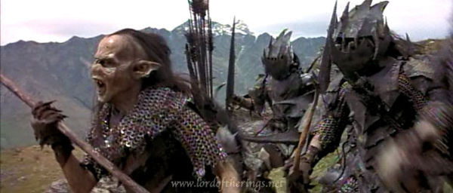
Figure 5 A group of Moria Goblins

About:
Small, cowardly, and weak, goblins are of little threat to Aragorn, except when they swarm like cockroaches. They fight with short-spears and daggers.
Health | 500
Damage per Attack | 200
- Moria Goblin Stats

Attack:
The goblin strikes with his spear forward, toward Aragorn’s chest.
Wind Up Time | Attack Time | Cooldown Time
6 frames/199.98ms | 3 frames/99.99 ms | 5 frames/165.5 ms
- Moria Goblin Attack

Lock/Unlock/Neutral
A1S1 | N
A1S2 | U
A1S3 | U
A2S1 | N
A2S2 | U
A2S3 | U
A3S1 | U
- Moria Goblin Lock/Unlock/Neutral

Enemy 2 – Armored Goblin
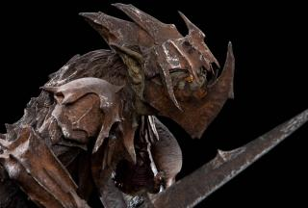
Figure 6 Armored Goblin

About:
Slightly less pathetic than their vanilla brethren, this unit fights with his sword and a shield. The extra armor makes it attack slightly slower as a result.
Health | 700
Damage per Attack | 500
- Armored Goblin Stats

Attack:
The goblin strikes with his sword, swinging wildly from top to bottom.
Wind Up Time | Attack Time | Cooldown Time
7 frames/233.31ms | 5 frames/165.5 ms | 5 frames/165.5 ms
- Armored Goblin Attack

Lock/Unlock/Neutral
A1S1 | L
A1S2 | L
A1S3 | N
A2S1 | N
A2S2 | L
A2S3 | N
A3S1 | U
- Armored Goblin Lock/Unlock/Neutral

Enemy 3 – Shelob Spawn
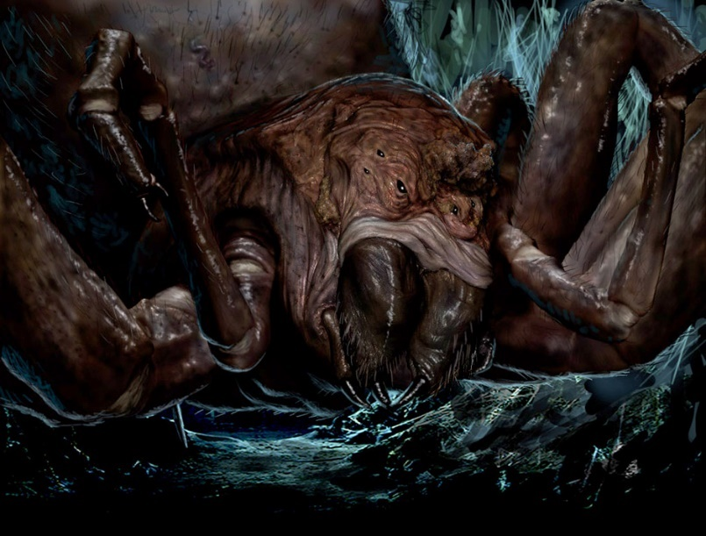
Figure 7 Shelob herself

About:
These large spiders are children of the monstrous Shelob and look like a miniaturized version of their mother. Quick on their feet and even quicker to violence, they are a very tough nut for Aragorn to crack.
Health | 900
Damage per Attack | 300
- Shelob Spawn Stats

Attack:
The spider pounces Aragorn, with both frontal legs raised, baring its fangs.
Wind Up Time | Attack Time | Cooldown Time
4 frames/99.99ms | 8 frames/266.4ms | 5 frames/165.5 ms
- Shelob Spawn Attack

Lock/Unlock/Neutral
A1S1 | L
A1S2 | L
A1S3 | U
A2S1 | L
A2S2 | L
A2S3 | U
A3S1 | N
- Shelob Spawn Lock/Unlock/Neutral

Enemy 4 – Uruk-Hai
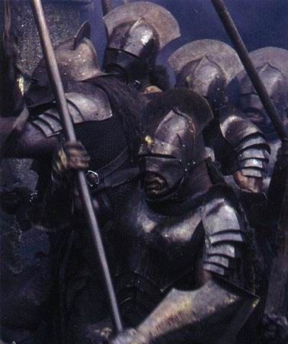
Figure 8 A group of Uruk-Hai

About:
The terrifying main force of Isengard, the Uruk Hai are abominations, somewhat resembling super-soldier versions of conventional Orcs. While Aragorn can defeat them one on one, they are not a trifling foe to encounter in large numbers and should always engaged with caution.
Health | 1200
Damage per Attack | 450
- Uruk-Hai Stats

Attack:
Using their large sword, the Uruk Hai takes a chop with a large arc.
Wind Up Time | Attack Time | Cooldown Time
9 frames/299.97ms | 3 frames/99.99ms | 10 frames/333.33 ms
- Uruk-Hai Attack

Lock/Unlock/Neutral
A1S1 | L
A1S2 | L
A1S3 | L
A2S1 | L
A2S2 | L
A2S3 | L
A3S1 | N
- Uruk-Hai Lock/Unlock/Neutral

Special Enemy 1 – Goblin Archer
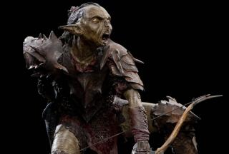
Figure 9 The Goblin Archer.

About:
This version of the weak Moria Goblin fights with a bow. They pepper Aragorn with arrows until he can safely approach them and take them down. Due to their lack of discipline, they do not put up a fight once Aragorn reaches them.
To successfully beat them, Aragorn must approach them and block any incoming arrows. If blocked this way, they deal no damage. Timing is of the essence, permitting Aragorn to safely approach them under the barrage.
Health | 400
Damage per Attack | 350
- Goblin Archer Stats

Attack:
Wind Up Time | Attack Time | Cooldown Time
9 frames/299.97ms | 3 frames/99.99ms | 10 frames/333.33 ms
- Goblin Archer Attack

Special Enemy 2 – Neekerbreekers
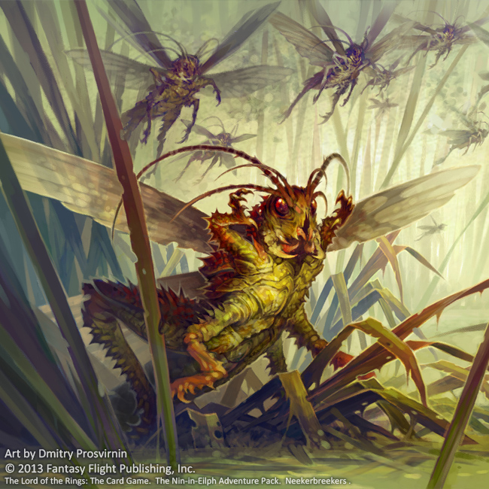
Figure 10 Angry Neekerbreekers

About:
These loud pests harass Aragorn and the Hobits as they make their way to Weathertop. While they pose no threat to anything other than seasonal crops, Neekerbreekers have the unfortunate tendency to be very loud when disturbed. At this point in the story, Aragorn is escorting the Hobits to Rivendell, Nazgûl in pursuit. Aragorn must walk around their hiding spots while navigating the grasslands on route to Weathertop, lest their cries warn the Nazgûl of the party’s location. There are goblins Aragorn must also deal with as he avoids combat near the insects further complicate matters.
Health | 1
Damage per Attack | 0
- Neekerbreekers Stats

Special Enemy 3 – Shegob Spiderlings
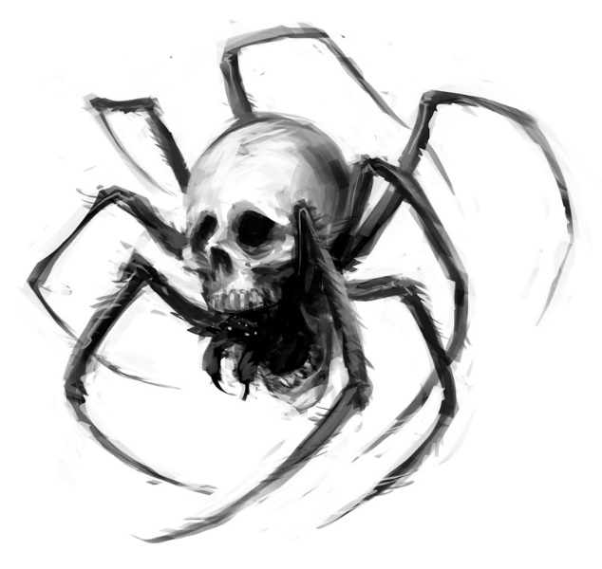
Figure 11 Shegob Spiderlings

About:
Spiderlings measure approximately a foot in length and are unable to harm Aragorn. They appear after bursting from egg sacks and scurry along the floor. After about 8 seconds of aimlessly running around the floor, they burrow underground, after which they reappear as Shelob Spawns. To kill them, players must run over them before this. Players that do not address these creatures quickly will find themselves overrun.
These creatures cause more fear and stress by their presence than by being actually dangerous; encounters with these creatures should give ample time to allow the player to safely dispose of them before they are a danger.
Health | 1
Damage per Attack | 0
- Spiderling Stats
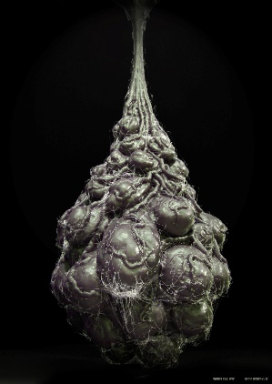
Figure 12 Spiderling Sack, before bursting

Bibliography
Figure 1: http://vignette1.wikia.nocookie.net/vsbattles/images/2/23/97404-the-lord-of-ring-aragorn.jpg/revision/latest?cb=20140910004901
Figure 2: S2 Controller https://images-na.ssl-images-amazon.com/images/I/41pX2kkg-HL.jpg Via Amazon
Figure 3: Aragorn http://www.desktopimages.org/pictures/2012/0926/1/brunettes-movies-men-the-lord-of-the-rings-aragorn-viggo-mortensen-warriors-swords-the-two-towers-pics-152652.jpg Via DesktopImages.org
Figure 4: Aragorn http://vignette2.wikia.nocookie.net/lotr/images/d/de/Sword.jpg/revision/latest?cb=20120728190733
Via LOTR Wikia
Figure 5: Goblins at the Siege of Moria http://vignette1.wikia.nocookie.net/lotrfanon/images/d/da/Goblins_at_the_siege_of_moria.jpg/revision/latest?cb=20070726191510 Via Lotrfanon Wikia
Figure 6: Goblin 1 http://wetaworkshop.com/assets/Uploads/Collectables/_resampled/CroppedImage320216-Crop36221129762-Merch-LOTR-Goblin-1.jpg Via WetaWorkshop
Figure 7: Shelob http://www.paulcampion.com/illustration/concept/ Via Paul Campion
Figure 8: Uruk-Hai http://vignette3.wikia.nocookie.net/lotr/images/7/79/Uruk_Hai.jpg/revision/latest?cb=20120209125456 Via One Wiki To Rule Them All
Figure 9: Goblin Archer http://wetaworkshop.com/assets/Uploads/Collectables/_resampled/CroppedImage320216-Crop11391810547-Merch-LOTR-Goblin-2.jpg
Figure 10: Neekerbeekers http://d8p.deviantart.com/art/Neekerbreekers-572380613
Figure 11: http://suptg.thisisnotatrueending.com/archive/41522153/images/1438132259172.jpg
Figure 12: Alien Chrysalis http://goldenarmor.com/alien-egg-sack/

Values subject to change; find them in the adjunct Excel document in the “Aragorn” Tab, in cells G84 for Unlocked and G85 for Locked.

